Control Systems Lab Name:___________________

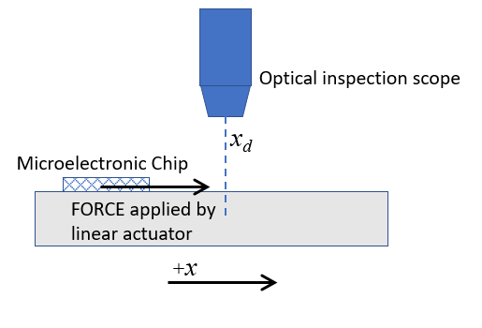
Prelab 4: In Class Assignment RIN:____________Section:__
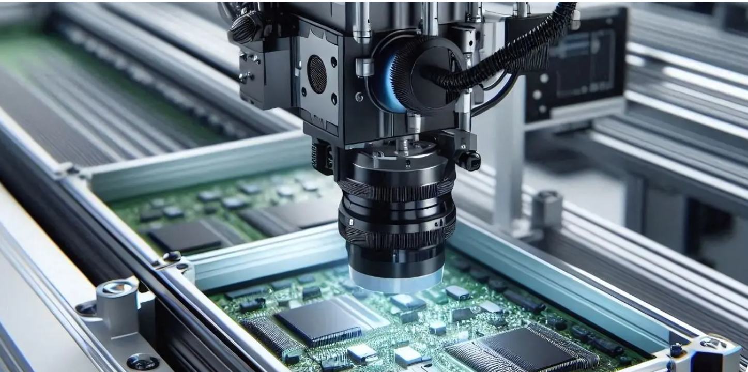
Source: https://averroes.ai/blog/aoi-semiconductor
- Consider a positioning stage in a semiconductor inspection tool. A linear actuator applies a force, $F$ (Newtons), to the stage carrying the microelectronic chip. An encoder provides stage position $, x$(meters). The target position under the inspection scope is denoted $x_{d}$. You want to control the position using a proportional controller. Draw the block diagram for the closed loop system. Label all signals and include units for each.

- The diagram below shows blocks in Simulink used to implement position control of the stage. The reference $x_{d}$ is obtained from a graphical user interface (GUI) in units of meters. An encoder provides a distance measurement of the stage in mm. A motor driver sends a force value to the linear actuator.
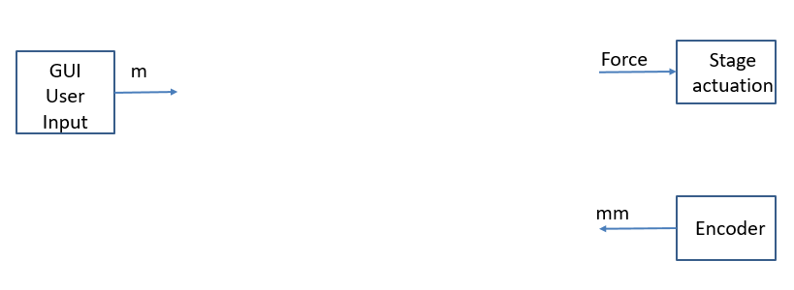
Complete the Simulink block diagram above, by hand, assuming a proportional control feedback system with gain, $K_{p}$(Newtons/meter). Include needed unit conversions. Label the blocks and signals, including units.

- What is the control law for this specific example?
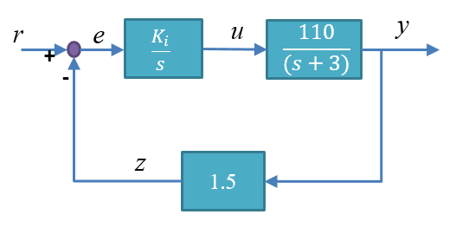
- Assume a compensator, plant, and sensor can be modeled by the transfer functions given in the figure:

- Write an equation (control law) for the actuation signal, u, as a function of the error signal, e.

- What is the Closed Loop Transfer Function (simplify this to a ratio of two polynomials)?

- What is the Characteristic Equation?

_______________________________________________________________________________________________
- Below is the control law equation for a PI compensator:
$$u\left(t\right)=K_{P}e\left(t\right)+ K_{I}\int{e\left(t\right)dt}$$
  - Draw a block diagram of this compensator by hand. Use Laplace transform notation for integral and derivative blocks, and label the input and output signals of the compensator.

- Derive the transfer function for this compensator (simplify this to a ratio of two polynomials)?

- Write the numerical implementation of the PID controller, $u\left(t\right)=K_{P}e\left(t\right)+K_{d}\frac{de(t)}{dt}+ K_{I}\int{e\left(t\right)dt}$

